**DATA VISUALIZATION PROJECT REPORT**

**PROJECT REPORT**

**ON**

HR Analytics Dashboard

Submitted by

**Nilesh Kumar**

**12004482**

Programme: Bachelor of Technology

Section: KM048

Course Code: INT233

Under the Guidance of

**Mrinalini Rana**

**Assistant Professor**

**Discipline of CSE/IT**

**School of Computer Science & Engineering**

**Lovely Professional University, Phagwara**

**DECLARATION**

I hereby declare that I have completed 5 DAYS under the guidance of Mrinalini Rana

.I declare that I have worked full dedication during 5 Days and my learning outcomes fulfill the requirements of training for the award of degree of B.tech. CSE, Lovely Professional  
University, Phagwara.

Date: 12/04/2023 Signature

Nilesh Kumar

Registration No: 12004482

**CERTIFICATE**

This is to certify that. Nilesh Kumar bearing Registration no.12004482 has completed INT233 project titled, **“*HR ANALYTICS DASHBOARD*”** under my guidance and supervision. To the best of my knowledge, the present work is the result of his/her original development, effort and study.

**Signature and Name of the Supervisor**

**Mrinalini Rana**

**Designation of the Supervisor**

**Assistant Professor**

**School of Computer Science & Engineering**

Lovely Professional University

Phagwara, Punjab.

Date: 12/04/2023

**ACKNOWLEDGEMENT**

I would like to express my gratitude towards my Teacher as well as Tableau for providing me the golden opportunity to do this wonderful project regarding ***HR ANALYTICS DASHBOARD***, which also helped me in doing a lot of homework and learning. As a result, I came to knowabout so many new things. So, I am really thank full to them.Moreover I would like to thank my friends who helped me a lot whenever I got stuck in some problem related to my course. I am really thankfull to have such a good support of them as they always have my back whenever I need. I have taken efforts in this project. However, it would not have been possible without the kind support and help of many individuals and organizations. I would like to extend mysincere thanks to all of them. Deepest thanks to our Trainer Mrinalini Rana for his guidance, monitoring, constant encouragement and correcting various assignments of ours with attention and care.

Table of Content

|  |  |  |
| --- | --- | --- |
| **Sr No.** | **Title** | **Page No.** |
| 1 | Introduction | 6 |
| 2 | Scope of the Analysis | 7 |
| 3 | Source of dataset | 8 |
| 4 | Analysis on dataset | 9 to 18 |
|  |  | 2 |
| 6 | References | 19 |
| 7 | Bibliography | 20 |

**INTRODUCTION**

An HR dashboard is a tool that provides a visual representation of HR metrics and data, allowing HR professionals and managers to easily monitor and analyze key HR performance indicators. The dashboard typically displays real-time data on various HR functions, such as employee engagement, turnover rates, recruitment and retention, training and development, and workforce demographics.

By presenting data in an easily understandable and visually appealing format, HR dashboards help organizations make data-driven decisions and identify areas for improvement. They also help HR professionals to monitor HR processes and policies, track progress towards goals, and assess the effectiveness of HR initiatives. HR dashboards can vary in complexity and design, depending on the needs and objectives of the organization. Some dashboards may be simple and provide basic information, while others may be more detailed and provide in-depth analysis of HR data. Ultimately, the goal of an HR dashboard is to provide actionable insights and help organizations optimize their HR strategies and practices.

**Scope of the Analysis**

The scope of the analysis for an HR dashboard will depend on the specific needs and objectives of the organization. However, some common areas that are typically included in an HR dashboard are:

1. Recruitment and hiring: This includes metrics such as time-to-fill, cost-per-hire, source of hire, and applicant tracking.
2. Employee retention: This includes metrics such as turnover rate, retention rate, and reasons for turnover.
3. Performance management: This includes metrics such as performance ratings, goals achieved, and development plans.
4. Compensation and benefits: This includes metrics such as average salary, total compensation, and benefits utilization.
5. Training and development: This includes metrics such as training hours per employee, completion rates, and effectiveness of training.
6. Workforce demographics: This includes metrics such as age, gender, ethnicity, and diversity.
7. Employee engagement: This includes metrics such as engagement surveys, pulse surveys, and feedback from employee satisfaction surveys.

By analyzing these areas, an HR dashboard can provide valuable insights into the performance and effectiveness of HR processes and policies. This can help organizations identify areas for improvement, make data-driven decisions, and optimize their HR strategies to meet their business objectives.

Source of dataset

[**https://docs.google.com/spreadsheets/d/1Rkxoxnv-**](https://docs.google.com/spreadsheets/d/1Rkxoxnv-) **kIg2flKoQ02BZtibiea4knoE/edit?usp=share_link&ouid=117523022860449557539&rtpof=true&sd=true**

**The source of the dataset for an HR dashboard will depend on the specific metrics and areas that the dashboard aims to analyze. Some common sources of data for an HR dashboard include:**

1. **HR information system (HRIS): Many organizations use HRIS software to manage employee data, including information on recruitment, performance, compensation, and benefits. An HR dashboard can pull data from the HRIS to provide real-time insights into HR processes.**
2. **Applicant tracking system (ATS): An ATS is a software application that manages the recruitment and hiring process. Metrics such as time-to-fill and source of hire can be pulled from the ATS to provide insights into recruitment effectiveness.**
3. **Performance management system: Many organizations use performance management software to track employee goals, performance reviews, and development plans. An HR dashboard can pull data from this system to provide insights into employee performance and development.**

Analysis on dataset

1)KPI

2) Attrition by Gender

3) DEPARTMENT WISE ATTRITION

4) No of Employee by Age Group

5)Job Satisfaction Rating

6) Education Field wise Attrition

7) Attrition Rate by Gender for different Age Group

8) HR ANALYSTIS DASHBOARD

**Analysis on dataset**

1. **KPI**

KPIs, or Key Performance Indicators, are specific metrics that an organization tracks to measure the success of its objectives. The source of the dataset for KPIs in an HR dashboard will depend on the specific KPIs being measured. Here are some examples of KPIs for an HR dashboard and their potential data sources:

1. Attrition by Gender

The source of the dataset for Attrition by Gender KPI in an HR dashboard can be the organization's HR information system (HRIS). The HRIS can provide data on the number of employees who have left the organization, along with information on their gender. This data can then be used to calculate the attrition rate for each gender.

1. ) DEPARTMENT WISE ATTRITION

The HRIS can also provide additional information on the reasons for attrition by department, such as voluntary resignations, retirement, or terminations. This data can help organizations identify patterns and trends in employee turnover by department and make informed decisions about retention strategies.

It's important to note that tracking department-wise attrition is just one aspect of measuring workforce management in an organization. Organizations may also want to track other HR metrics, such as employee engagement, performance management, and training completion, and use a range of data sources to provide a comprehensive view of their HR operations.

1. No of Employee by Age Group

To collect data on the age of employees, HRIS may require employees to provide their date of birth or age when they join the organization or complete onboarding paperwork. This data can then be used to categorize employees into different age groups for analysis, such as 18-25, 26-35, 36-45, 46-55, and 56 and above.

The HRIS can also provide additional demographic information on employees, such as gender and ethnicity, which can be used in combination with the age data to track diversity and inclusion efforts within the organization.

5)Job Satisfaction Rating

The survey questions can be designed to cover different aspects of job satisfaction, such as compensation, benefits, work-life balance, career growth opportunities, job security, and company culture. The survey can use rating scales or Likert scales to capture employees' responses, such as strongly agree, agree, neutral, disagree, and strongly disagree.

The survey can be conducted on a regular basis, such as quarterly or annually, to track changes in job satisfaction levels over time. The survey results can be compiled and analyzed using statistical tools to generate key metrics, such as the overall job satisfaction rate, the satisfaction rate by department, and the satisfaction rate by different demographic groups, such as age, gender, and ethnicity.

The survey can also include open-ended questions to capture employees' feedback and suggestions for improvement. This feedback can be used to inform HR policies and initiatives aimed at improving employee satisfaction and retention.

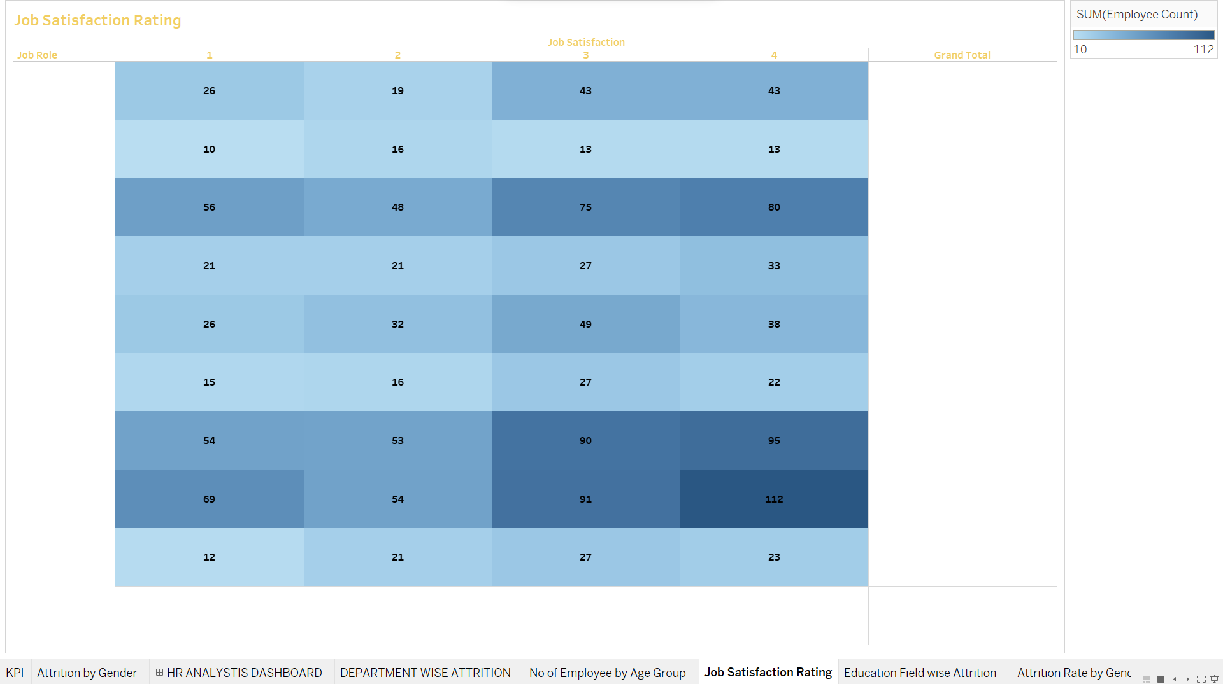

1. Education Field wise Attrition

The HRIS can also provide additional information on the reasons for attrition by education field, such as voluntary resignations, retirement, or terminations. This data can help organizations identify patterns and trends in employee turnover by education field and make informed decisions about retention strategies.

Tracking attrition by education field can help organizations identify areas where they may need to invest in training and development programs to retain employees with critical skills and knowledge. It can also help organizations assess the impact of their recruitment strategies in attracting employees with the right educational background for different job roles.

It's important to note that education field-wise attrition is just one aspect of measuring workforce management in an organization. Organizations may also want to track other HR metrics, such as employee engagement, performance management, and training completion, and use a range of data sources to provide a comprehensive view of their HR operations.

1. Attrition Rate by Gender for different Age Group

To calculate the attrition rate by gender for different age groups, the total number of employees who left the organization during a given time period is divided by the total number of employees in that age group and gender at the beginning of the same time period. For example, if 10 female employees between the ages of 26-35 left the organization out of a total of 100 female employees between the ages of 26-35 at the beginning of the year, the attrition rate for this age group and gender would be 10%.

By tracking attrition rates by gender and age group, organizations can gain insights into their workforce demographics and identify patterns and trends in employee turnover. This data can be used to inform retention strategies, such as targeted training and development programs, flexible work arrangements, and employee engagement initiatives.

It's important to note that attrition rate by gender for different age groups is just one aspect of measuring workforce management in an organization. Organizations may also want to track other HR metrics, such as employee engagement, performance management, and training completion, and use a range of data sources to provide a comprehensive view of their HR operations.

**HR ANALYTICS DASHBOARD**

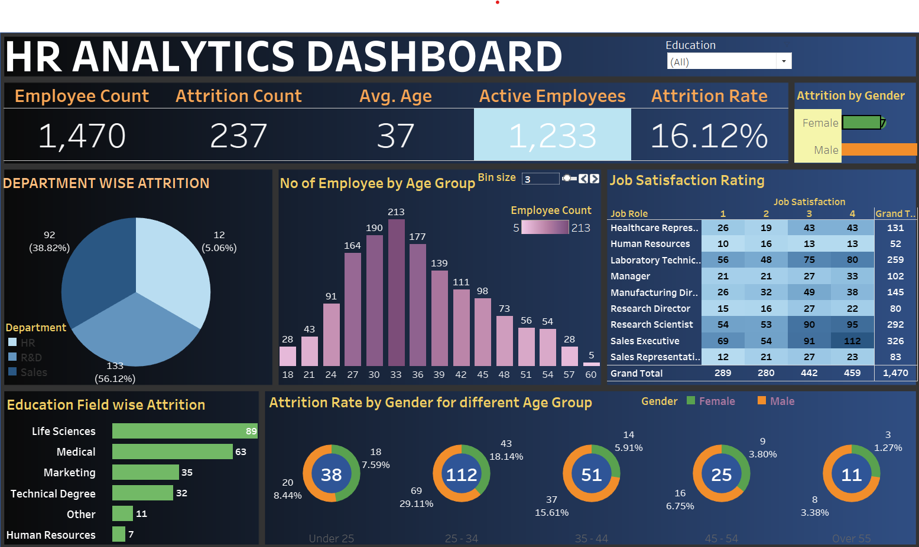

References

**Here are some references that may be useful for an HR dashboard:**

* **"HR Metrics and Analytics: Use and Impact." Society for Human Resource Management. https://www.shrm.org/hr-today/trends-and-forecasting/research-and-surveys/Documents/SHRM-Analytics-Report-2016.pdf**
* **"HR Analytics: Definition, Benefits, Key Metrics, and Trends." People Matters. https://www.peoplematters.in/article/hr-analytics/hr-analytics-definition-benefits-key-metrics-and-trends-28201**
* **"HR Dashboard: Examples, Metrics, and Best Practices." PeopleGoal. https://www.peoplegoal.com/blog/hr-dashboard-examples-metrics-and-best-practices**
* **"How to Build an HR Dashboard: 5 Key Metrics." Namely. https://blog.namely.com/blog/how-to-build-an-hr-dashboard-5-key-metrics**
* **"HR Metrics: The Most Important Metrics Every HR Leader Should Be Tracking." ClearCompany. https://blog.clearcompany.com/hr-metrics-the-most-important-metrics-every-hr-leader-should-be-tracking**
* **"7 HR Analytics Every Manager Should Know." Better Buys. https://www.betterbuys.com/hr/hr-analytics/**

**Bibliography**

**Here are some sources you can use to gather more information about Attrition Rate in an HR dashboard:**

* **"The Basics of Employee Attrition Rate Calculation." SHRM. Society for Human Resource Management. https://www.shrm.org/resourcesandtools/tools-and-samples/how-to-guides/pages/how-to-calculate-employee-attrition-rate.aspx**
* **"Attrition Rate Definition and Formula." The Balance Careers. https://www.thebalancecareers.com/attrition-rate-1918156**
* **"What is Employee Attrition Rate and How to Calculate it?" HR Technologist. https://www.hrtechnologist.com/articles/employee-engagement/what-is-employee-attrition-rate-and-how-to-calculate-it/**
* **"How to Use Attrition Rates to Understand and Improve Employee Retention." BambooHR. https://www.bamboohr.com/blog/how-to-use-attrition-rates-to-understand-and-improve-employee-retention/**
* **"Understanding Attrition: A Guide for HR Professionals." Workable. https://resources.workable.com/tutorial/attrition**